sjsytu
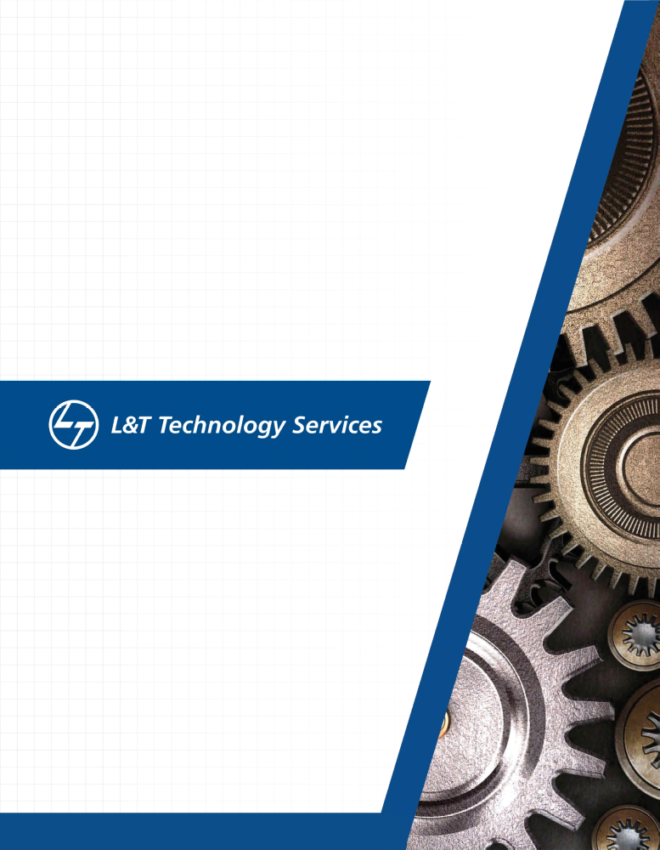./


PS No.99003140
Linux OS and Porgramming
Goal
To get familiar with Linux OS and commnds to interact with shell.

Activity - 1

- To find the total number of lines in a file.
- Finding the total number of empty lines.
- Finding the number of lines with single character.

Learning outcomes

- Usage of differnt commands to read the number of lines
- Usage of commands like wc and grep.
- Learnt to use file accessign and appending commands along with filter commnds.

Activity - 2

- Valgrind chek on file to check for memory leaks and append he error message to new text file.
- CPP check on file and append he messge to new file.

Learning outcomes

- Using valgrind to check for memory leaks and detecting any memory leaks in program.
- Using cppcheck to check for code quality and cpp check of the file.
- Usage of file handling commands to access and append.

Activity - 3

Static library and Dynamic library.

Learning outcomes

- Implementing C program builder.
- Using utilities and implementing codes in separate header and C files.
- Created our library and learnt to link that to a static and dynamic type.
- Usage of idconfig to link a dynamic library.
- Implementing makefile for the same.

Activity - 4

On OS and System calls and processes

Learning outcomes

- How to make system call and implement different system calls.based on file descriptors by any process.
- How to handle and run a process.
- How to create parent and child process.
- Creating mulitple child processess.
- Kill or stop processs.
- Implementing how to wait a process and override in a child process to give our own.

